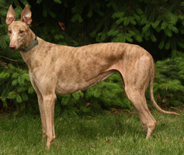 | LOST GREYHOUND  “Name”
(add photo here)
Color__________ Sex____ Tag#_____

If won’t come to you, Please do not chase

Call Owner ______________

Call Greyhound Pet Adoption Northwest, 800-767-5139

Area where lost_________________ Date_______

